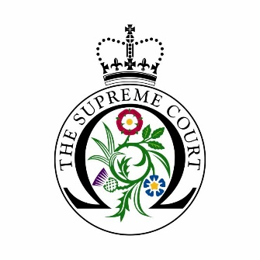

UK Supreme Court Educational Virtual Tour Booking Form

Name and address of the educational institution:
Name and contact details of the group organiser:
Booking code (if applicable):
Date(s) and time(s) preferred for the virtual tour
(Virtual tours last around 45 minutes and can take place Monday to Thursday at 10am, 11am, 2pm and 3pm, as well as Fridays at 10am).
Do you have Microsoft Teams?
(Microsoft Teams is the platform used for the virtual tours. You will be sent a Microsoft Teams link by the UKSC guide once the date and time is confirmed)
Yes ☐ │ No ☐
How many students will join the Microsoft Teams meeting for the virtual tour?
Does anyone in the group have any requirements? (An accessible PowerPoint presentation can be used)
Please confirm that:
Everyone will join the Microsoft Teams meeting on time □
The teacher will remain on the meeting during the length of the virtual tour □
What subject(s)/course(s) are your students studying?
Are there any specific curriculum areas that you would like us to cover?
How did you hear about us?
Additional comments:
For schools only: What is your school’s Ofsted free school meals rating?

Lower than average ☐│ Average ☐│ Higher than average ☐
For schools only: What is your school’s Ofsted rating on English as an Additional Language?
Lower than average ☐│ Average ☐│ Higher than average ☐
For schools only: Is the proportion of pupils with Special Educational Needs and Disabilities (SEND):
Lower than average ☐│ Average ☐│ Higher than average ☐

Please complete this booking form and send it to enquiries@supremecourt.uk
Thank you.

